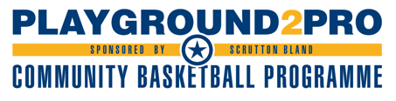
October Half Term Camp

Player Name
Date of Birth
Emergency Contact
Parent Email
Medical Conditions
Which camp are you booking (u18/u16’s or u14/u12’s)
Number of Days

The cost for the camp is £25 per day or £40 for two days.

Once payment has been received, we will contact you to confirm your place. Prior to camp we will circulate our site map, outlining the one-way system that will be in use when signing in each day.

On arrival, players will complete our daily ‘COVID screening’ and will then have their temperature taken. Any players that do not pass to COVID tests will not be allowed to participate in camp and will be asked to leave the site.

Please book your place by completing the above form and paying for camp by Bank Transfer. We will not be accepting any cash/cheque payments and your place will not be confirmed until payment is received.

If camp is cancelled due to COVID, you will receive a full refund. However, refunds are not available for injury/illness as we are working with a limited amount of spaces.

Account Name: IBA Coaching
Account: 68802277
Sort Code: 53-61-24
Reference: RTP Camp followed by name of player

